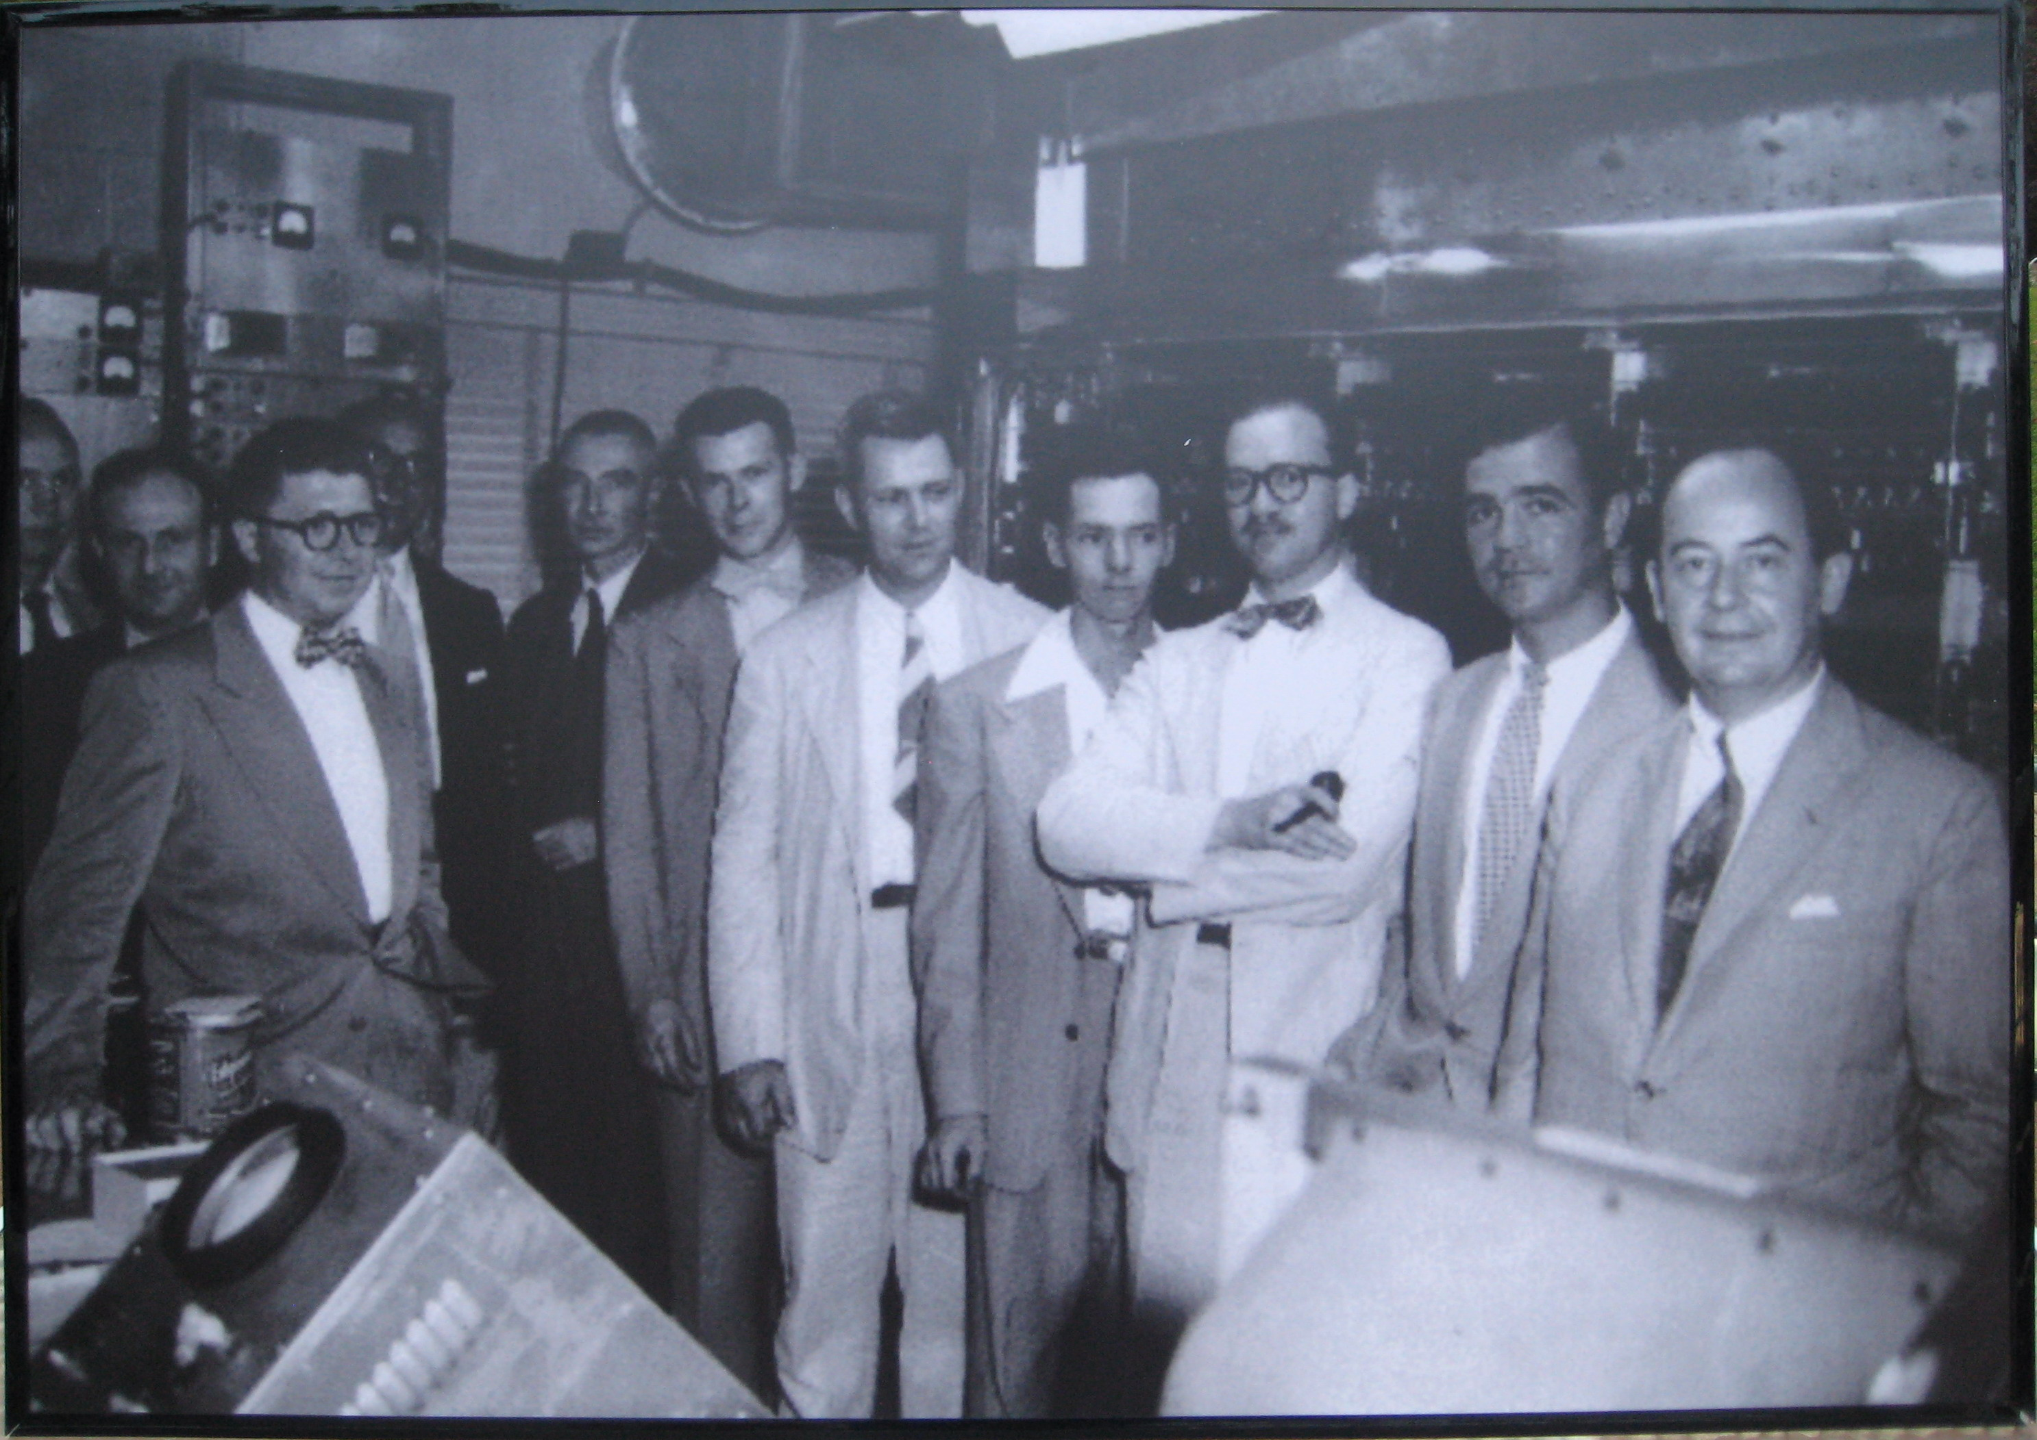

The computer at the Institute for Advanced Studies at Princeton.

From extreme left to right:
- Gordon Kent
- Ephraim Frei
- Gerald Estrin
- Louis Strauss
- J. Robert Oppenheimer
- Richard Melville
- Julian Bigelow
- Norman Ensley
- James Pomerene
- Hewitt Crane
- John von Neumann

The picture is believed to have been taken in 1952 or early 1953. Willis Ware, who also worked on the project, had left in 1951 for North American Aviation and then Rand.

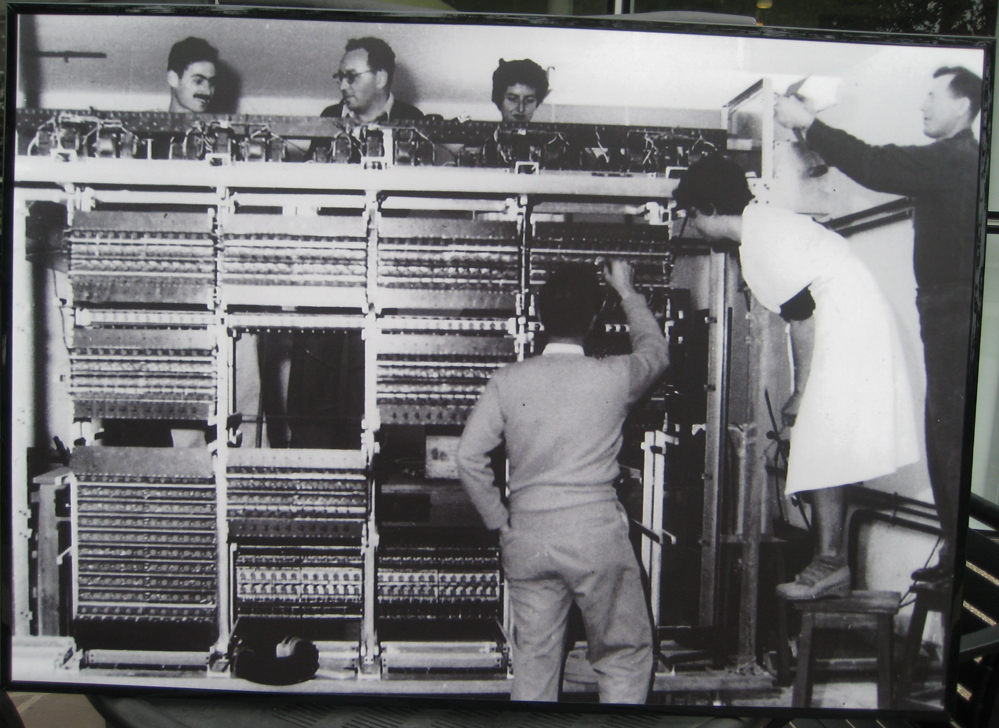

The WEIZAC computer in Israel; early 1950s.

Top, from left:
- Micha Kedem, principal technician
- Zvi Riesel, group development leader
- Thelma Estrin, engineer
With his back to the camera:
- Gerald Estrin
On the stools, from left:
- Ruth Be’eri, technician
- ??, sheet metal technician
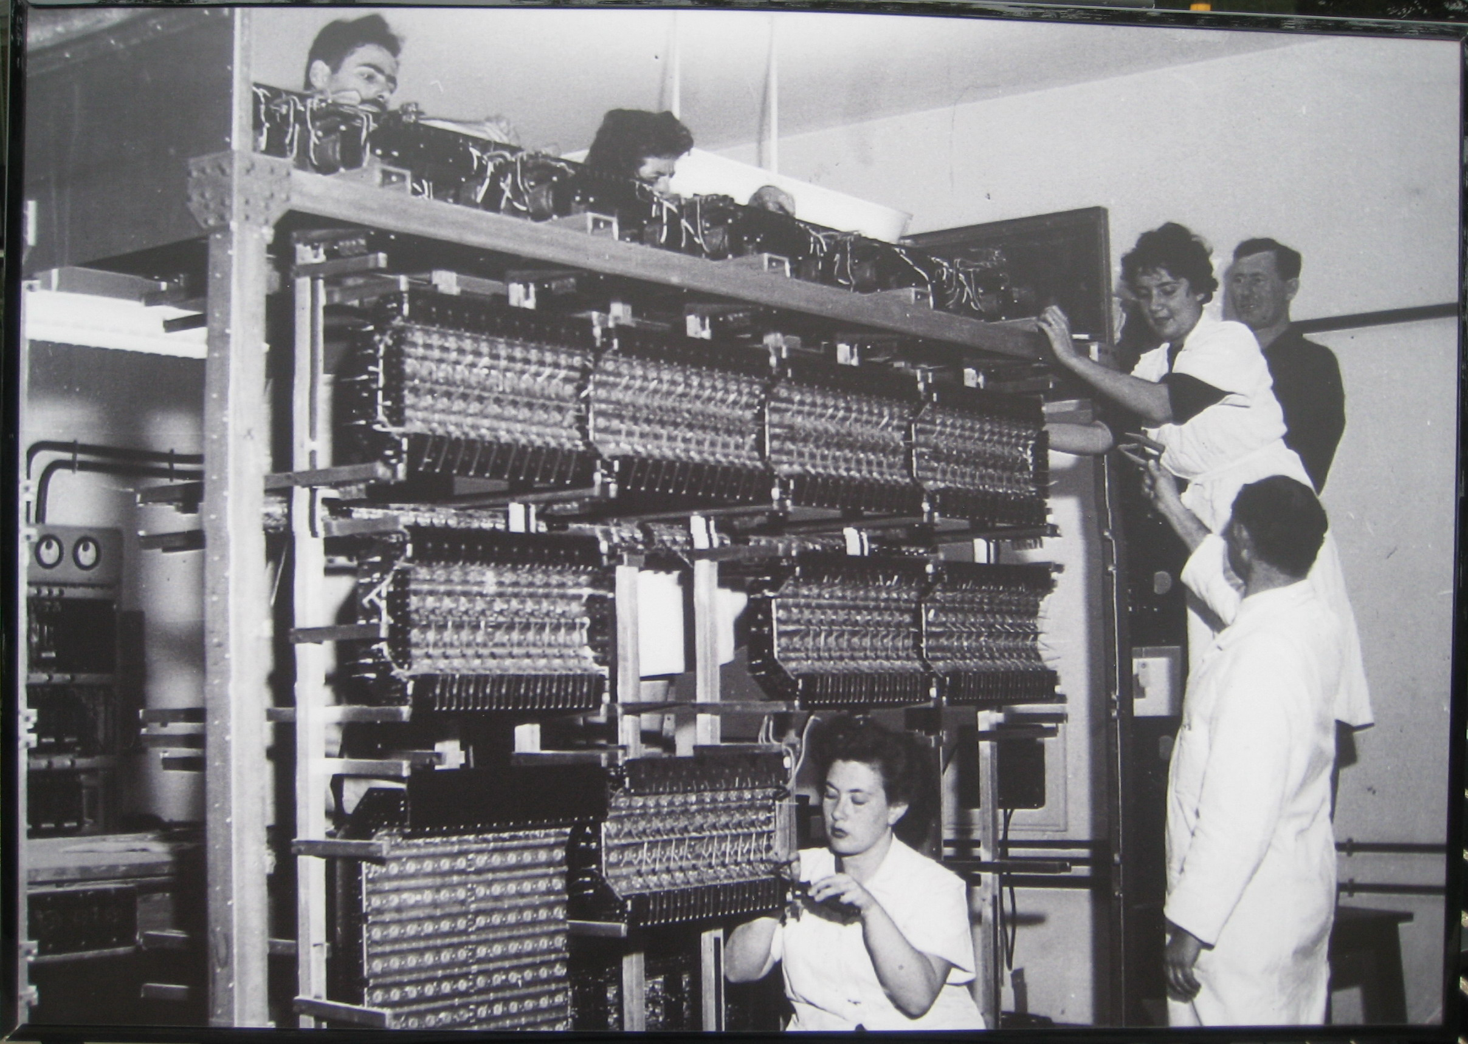

The WEIZAC computer in Israel; early 1950s.

Top, from left:
- Micha Kedem, principal technician
- Thelma Estrin, engineer
- Ruth Be’eri, technician (“Third generation Israeli tech” – G. Estrin)
- ??, sheet metal technician
With his back to the camera:
- ??
Bottom:
- Shoshana Rosenberg (“Emigrated from Hungary, started washing floors and later in charge of punched card files” -- G. Estrin)

